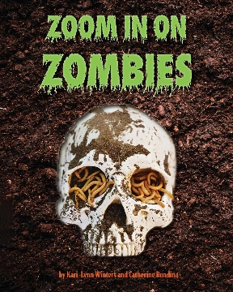
Zoom in on Zombies
by Kari-Lynn Winters and Catherine Rondina

Discussion Questions
- What characteristic is most important when deciding if something is a zombie?
- Did anything in the book surprise you? Scare you? Make you less scared?
- Have you ever had food go bad or rot? What happened to it? (Turning green? Growing fuzz? Smelling bad?)
- This book introduces us to plants that look dead but come back. When tree lose all their leaves in the winter then grow them back in the spring, does that make them zombies too? Are there other examples you can think of that come back in the spring?
- The last chapter introduces us to zombie allies. How do you feel about the ways we use these allies in our daily lives?
- Some of the examples in this book are silly and some are very serious. Do you think zombies exist in real life?

