Skwxwú7mesh to English Crossword Puzzle
Ava and Jake get to know the nature around them with their chésha (mother) Styawat and s7ekw’i7te (cousin) AÍíÍa7.
On the next page, find the English plant words to match the Skwxwú7mesh (Squamish) ones! You can use the plant profiles section of the book if you get stuck.
ACROSS  2. KáÍkay  4. Tl’asíp  6. Skw’ekwchsáý  7. Kw’enikw’ay  8. Yetwánaý  10. Kwe7úpay̓  12. Si7semáchxw | DOWN  1. T’ákw’emaý  2. Xápaýay  3. Schi7i7áý  5. K’emeÍáý  6. KwÍayus  8. Nástem̓aý  9. Séliýaý  11. T’áka7aý

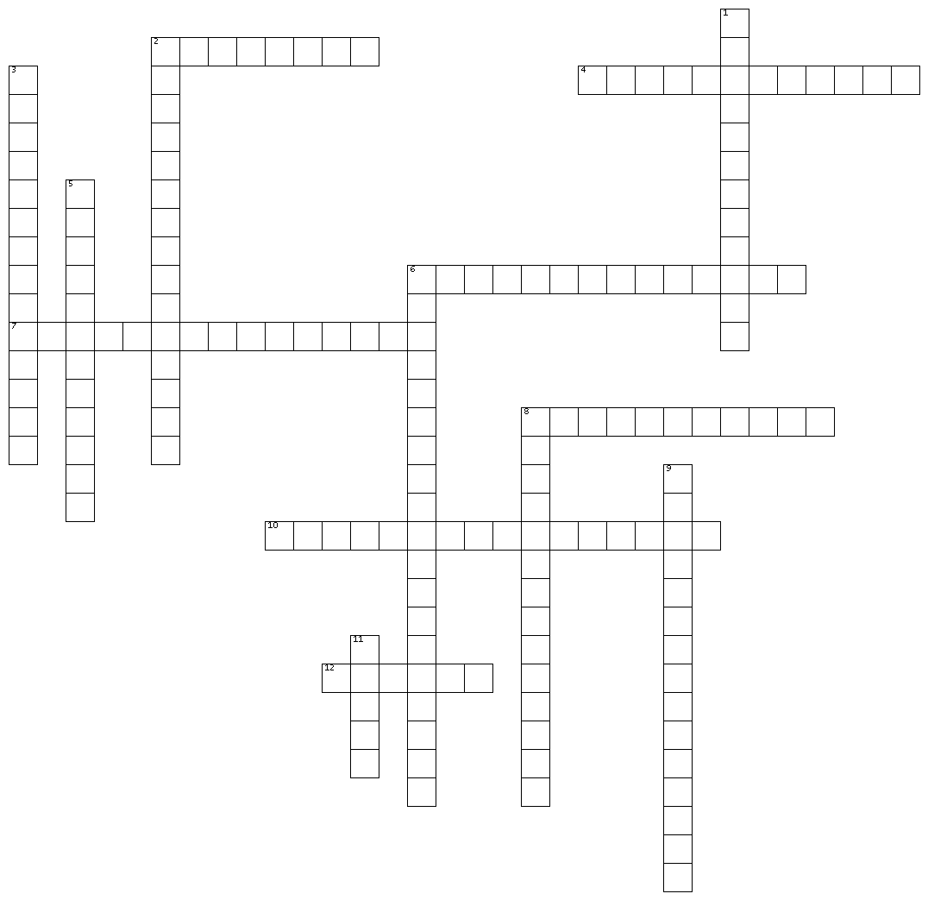
Skwxwú7mesh to English Crossword Puzzle
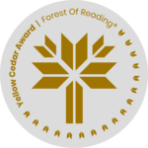
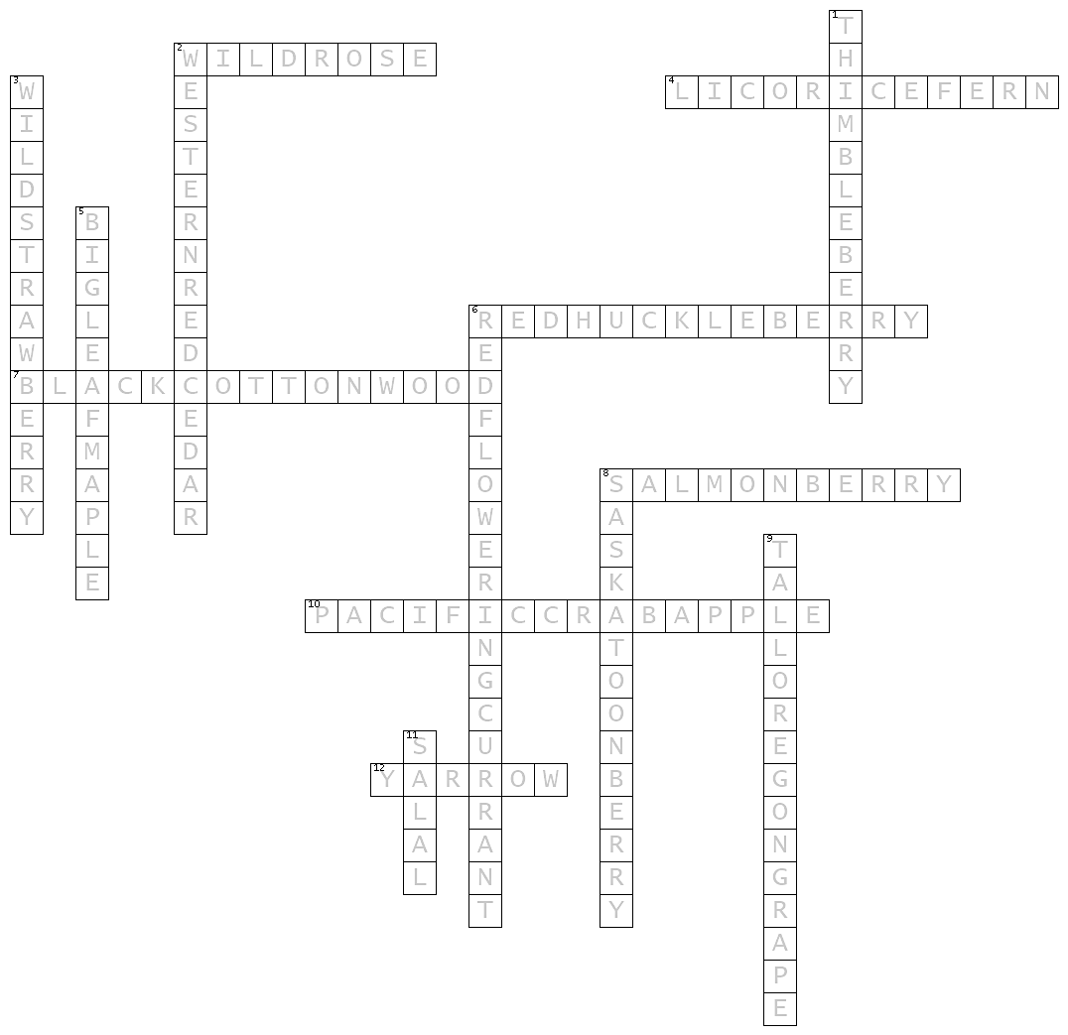
Skwxwú7mesh to English Crossword Puzzle Answers

ACROSS  2. KáÍkay – Wild Rose  4. Tl’asíp – Licorice Fern  6. Skw’ekwchsáý – Red Huckleberry  7. Kw’enikw’ay – Black Cottonwood  8. Yetwánaý – Salmon Berry  10. Kwe7úpay̓ – Pacific Crab Apple  12. Si7semáchxw - Yarrow | DOWN  1. T’ákw’emaý - Thimbleberry  2. Xápaýay – Western Red Cedar  3. Schi7i7áý – Wild Strawberry  5. K’emeÍáý – Big Leaf Maple  6. KwÍayus – Red Flowering Currant  8. Nástem̓aý – Saskatoon Berry  9. Séliýaý – Tall Oregon Grape  11. T’áka7aý - Salal

