At the end the story, all the plants were identified with their Skwxwú7mesh name, its pronunciation (how you say it), its English name, and its Latin name.

On the next page, create your own plant profile for a plant that is found in your community or region of the province. Draw and label your plant with the plant’s English name, Latin name, and its name in an Indigenous language that is used in your community.

Research to match the information found in the book. On a piece of paper, record:
- The habitat of your plant
- Its uses
- Safety tips for handling your plant
- How you harvest your plant

Plant Profiles
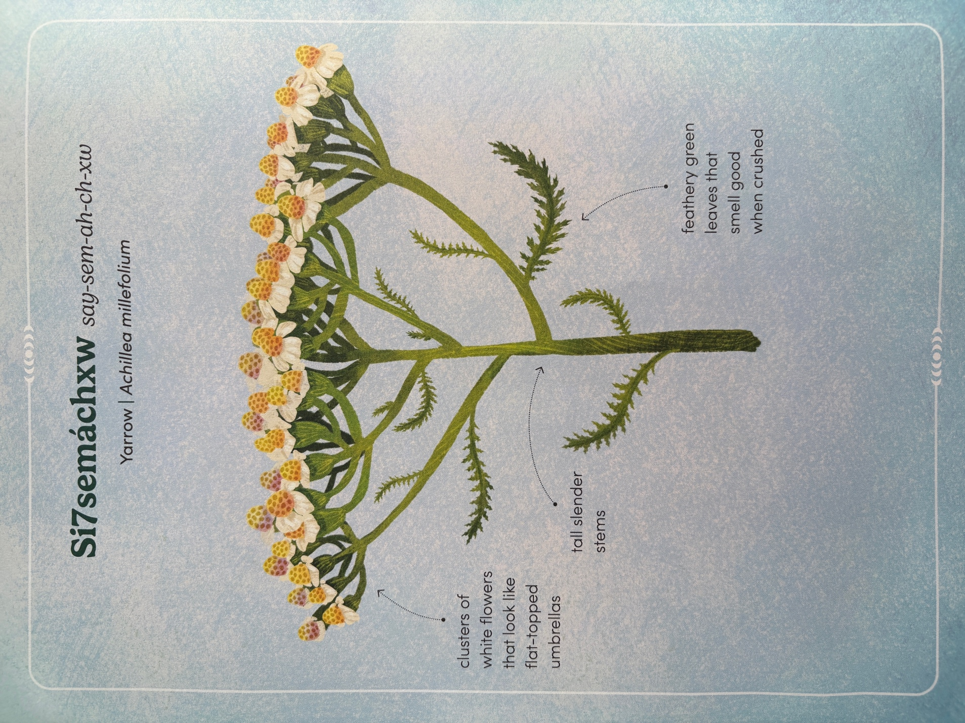
Plant Profiles – Plant Illustration

