Word Search

Find some of the words that are important to Dom’s experience in “The Dark Won’t Wait”
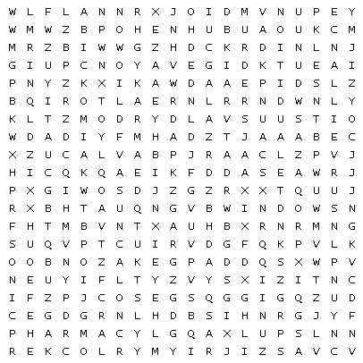
audition  carburetor  pharmacy  rehearsal | vandalizing  baseball  locker  pizza | Satan Wagon  Window  blackout | murder  realtor  surveillance


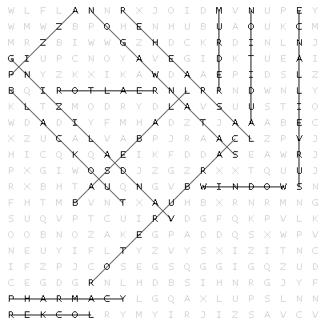
Word Search Answers

